
Tertiary Infotech Academy Pte Ltd
UEN: 201200696W
LEARNER GUIDE
For
WSQ Technical Drawing with AutoCAD
TGS Ref No: TGS-2021005538
Conducted by
Tertiary Infotech Academy Pte Ltd
UEN: 201200696W
Version 13

DOCUMENT VERSION CONTROL RECORD
Version Number | Effective Date of Release | Summary of Included Changes | Author
11 | 18 August 2026 | Legacy release — learner guide aligned to master trainer slides v11. | Dr Alfred Ang
12 | 18 August 2026 | Full single-source regeneration with 16 step-by-step labs, drawing-reading reference, assessment preparation guidance and glossary. | Dr Alfred Ang
13 | 21 August 2026 | DWG integration release: strengthened Labs 1, 8–12, 15 and 16 with active practice files, repaired the Lab 12 Landscaping_REV1 relative Xref dependency, and retained all detailed procedures in the Learner Guide and lab packs for alignment with the concept-led v13 deck. | Dr Alfred Ang

TABLE OF CONTENTS
Introduction 4
Course Learning Outcomes 4
Before You Start — Environment Setup 4
Topic 01 — Getting Started with AutoCAD (A1 · K1) 5
Lab 1 — Setting Up a New Drawing 5
Topic 02 — Technical Drawing with AutoCAD (A2 · K2) 6
Lab 2 — Creating Lines and Coordinates 7
Lab 3 — Circles, Rectangles and Polygons 8
Lab 4 — Polylines, Arcs, Ellipses and Splines 10
Lab 5 — 2D Isometric Drawing 11
Topic 03 — Modifying Objects (A3 · K3) 12
Lab 6 — Move, Copy, Rotate and Offset 13
Lab 7 — Trim, Extend, Fillet and Chamfer 14
Lab 8 — Mirror, Stretch, Scale and Arrays 15
Topic 04 — Organizing Objects (A4 · K4) 17
Lab 9 — Object Properties and Layers 17
Lab 10 — Grips, Hide and Isolate 18
Lab 11 — Blocks, Attributes and Part Lists 20
Lab 12 — External References and PDF Import 21
Topic 05 — Design Documentation (A5 · K5) 22
Lab 13 — Text and Text Styles 22
Lab 14 — Dimensions, Multileaders and Part-List Tables 23
Lab 15 — Hatching and Detail Finishing 25
Lab 16 — Layouts, Viewports and Plotting 26
Reading Technical Drawings — Quick Reference 27
Preparing for the Assessment 28
Glossary 28

Introduction
This Learner Guide accompanies the WSQ course WSQ Technical Drawing with AutoCAD (TGS-2021005538), conducted by Tertiary Infotech Academy Pte Ltd. It provides step-by-step instructions for all 16 hands-on labs, organised by the five course topics, aligned to the Skills Framework TSC Technical Drawing (DSN-TDR-3005-1.11).
Use this guide alongside the course slides and the lab folders in labs/ of the course repository. Each lab folder contains this guide's instructions as README.md, a printable PDF instruction sheet, and the AutoCAD DWG data files for that lab. The final assessment is open book: you may refer to the slides, this Learner Guide and other approved materials.

Course Learning Outcomes
- LO1: Read and visualize AutoCAD technical drawings
- LO2: Produce 2D and 3D technical drawings using AutoCAD
- LO3: Create part lists using AutoCAD
- LO4: Create AutoCAD design documentation
- LO5: Produce design specification using AutoCAD

Before You Start — Environment Setup
What you need
- A Windows PC (or Mac) with AutoCAD installed — AutoCAD 2021 or later (any recent release works; the free 30-day trial or an education licence is fine).
- Download AutoCAD from https://www.autodesk.com/products/autocad/free-trial or the education community at https://www.autodesk.com/education.
- The course lab files — the labs/ folder of the course repository (one folder per lab: DWG data files, PDF instruction sheet and README).
- A mouse with a scroll wheel — zooming and panning with the wheel is essential for CAD work.
Set up AutoCAD for the course
- Start AutoCAD and choose the Drafting & Annotation workspace.
- New drawings in this course start from the metric template acadiso.dwt.
- Keep the status bar visible — grid, snap, ortho, polar tracking and object snap are used in every lab.
- Copy the labs/ folder to your Documents so you can open and save the lab drawings freely.
Conventions used in every lab
- Commands are typed at the command line or picked from the ribbon; the short alias is shown in brackets, e.g. LINE (L).
- The → arrow chains a command's prompts, e.g. 'C → D → 40' means run CIRCLE, choose Diameter, type 40.
- Coordinates: absolute 100,50 · relative @50,0 · polar @50<30.
- Save your work as <lab>-mine.dwg so the supplied solution files stay untouched.
- Every lab ends with a 'Check your work' test — verify before moving on.

Topic 01 — Getting Started with AutoCAD (A1 · K1)
AutoCAD User Interface · Workspace Settings · Navigation · Units
Key concepts
- User interface — Application menu, Quick Access Toolbar, ribbon tabs and panels, drawing area, command window and status bar.
- Workspaces — Drafting & Annotation, 3D Basics and 3D Modeling — task-oriented sets of ribbons, menus and palettes.
- Model vs paper space — Design at 1:1 in model space; compose scaled drawing sheets in paper-space layouts.
- Precision aids — Grid and snap, ortho mode, polar tracking, object snaps and dynamic input keep every pick exact.
- Navigation — Zoom, pan, ViewCube and the wheel mouse move you around a drawing without changing it.
- Units and limits — UNITS sets the length/angle format and precision; LIMITS frames the working area of the drawing.

Lab 1 — Setting Up a New Drawing
Objective: LO1 — read and visualize AutoCAD technical drawings; set up a drawing environment (A1, K1).
Goal: Create and verify a metric drawing environment, compare saved workspace and drafting-setting examples, then open a finished drawing and practise reading it with zoom, pan and ViewCube.
You'll produce
A correctly configured metric drawing saved as DWG, a settings audit, and confident navigation of an existing technical drawing. (Commands: ACADISO template, UNITS, LIMITS, DSETTINGS, WSCURRENT, ZOOM, PAN, ViewCube.)
Step-by-step
1. Start AutoCAD and create a new drawing from the ISO metric template
NEW → acadiso.dwt
2. Open workspaces.dwg, compare the available workspaces, then switch to Drafting & Annotation
OPEN workspaces.dwg → WSCURRENT → Drafting & Annotation
3. Set decimal millimetres with 0.00 precision and decimal degrees for angles
UNITS → Insertion scale: Millimetres → Length: Decimal, 0.00
4. Frame an A3-sized working area with drawing limits, then zoom to it
LIMITS → 0,0 → 420,297 | ZOOM → All
5. Open drafting-settings.dwg and audit grid, snap, ortho, polar and object-snap settings
OPEN drafting-settings.dwg → DSETTINGS · F7 · F9 · F8 · F10 · F3
6. Open lab01-table.dwg and navigate it: wheel-zoom, pan, zoom window and zoom extents
OPEN lab01-table.dwg → Z → W / Z → E
7. Identify the views, dimensions and title information in the drawing, then save your setup file
SAVEAS → lab01-setup.dwg
Check your work
INSUNITS reports millimetres, limits are 420 × 297, Drafting & Annotation is current, the precision-aid audit is complete, and lab01-setup.dwg reopens with the settings intact.
Note: This lab's data files and printable instructions are in labs/lab-01-setting-up-a-new-drawing/.

Topic 02 — Technical Drawing with AutoCAD (A2 · K2)
Basic AutoCAD Operations · Drawing Objects · Isometric Drawing
Key concepts
- Lines & polylines — LINE draws separate segments; PLINE creates one connected object of line and arc segments.
- Circles & arcs — Circles by centre/radius or diameter; arcs by combinations of start, centre, end, radius and angle.
- Rectangles & polygons — RECTANG builds closed rectangular polylines; POLYGON draws 3–1024-sided regular polygons.
- Ellipses, splines & points — Ellipses from axis endpoints; splines as smooth curves through fit points; points as snap nodes.
- Construction geometry — Construction lines (XLINE) and rays give infinite reference lines for projecting views.
- 2D isometric drawing — ISODRAFT turns on isometric planes so a flat drawing represents a 3D projection.

Lab 2 — Creating Lines and Coordinates
Objective: LO2 — produce 2D technical drawings using AutoCAD (A2, K2).
Goal: Draw the outline of practice drawing EX-1 using the LINE and PLINE commands with absolute, relative and polar coordinate entry, working from its dimensioned drawing sheet.
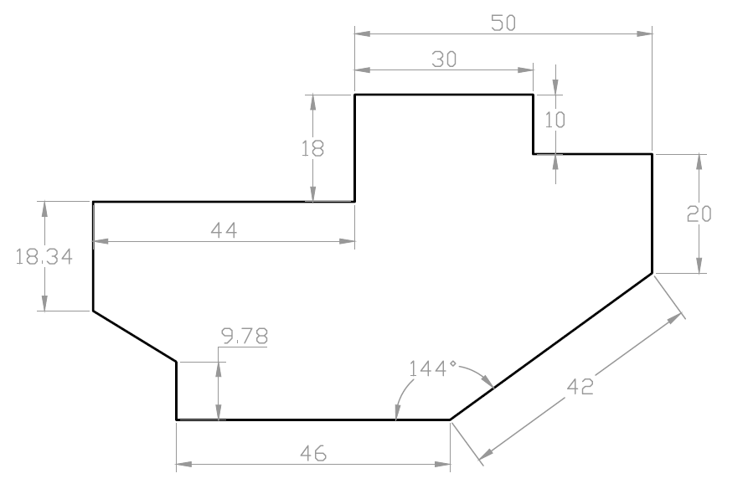
Lab 2 — the drawing you'll produce
You'll produce
The completed EX-1 profile drawn to size, matching the supplied solution DWG. (Commands: LINE, PLINE, coordinate entry (@dx,dy · @dist<angle), ORTHO, dynamic input.)
Step-by-step
1. Open the EX-1 drawing sheet (ex1-drawing-sheet.pdf) and study the dimensions
2. Start a new acadiso drawing and draw the first edge with absolute coordinates
L → 0,0 → 100,0
3. Continue the profile with relative coordinates for each dimensioned edge
@0,50 · @-30,0 · @20<135
4. Use ortho (F8) and polar tracking (F10) for the horizontal and vertical segments
F8 · F10
5. Close the profile back to the start point and check it forms one closed loop
C (Close)
6. Compare your result against the solution file ex1.dwg, then save
OPEN ex1.dwg → SAVEAS ex1-mine.dwg
Check your work
Your outline closes exactly (LIST shows the final vertex at 0,0) and overlays the solution ex1.dwg with no visible deviation.
Note: This lab's data files and printable instructions are in labs/lab-02-creating-lines-and-coordinates/.

Lab 3 — Circles, Rectangles and Polygons
Objective: LO2 — produce 2D technical drawings using AutoCAD (A2, K2).
Goal: Complete practice drawing EX-2 by adding circles (centre-radius, diameter, 2P/3P and Tan-Tan-Radius), a rectangle with chamfered/filleted corners and inscribed/circumscribed polygons.
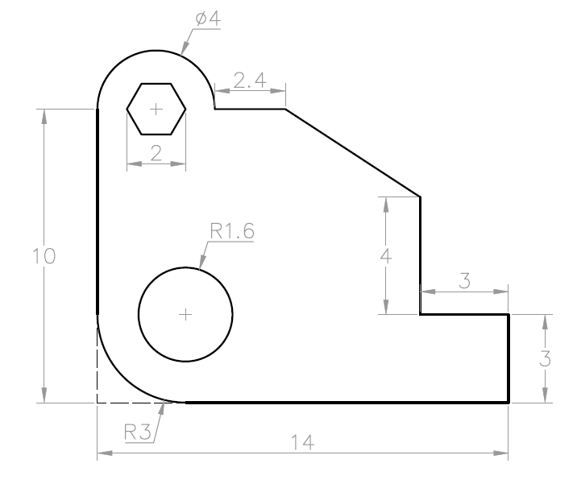
Lab 3 — the drawing you'll produce
You'll produce
The completed EX-2 drawing with all holes, rectangles and polygons placed to the sheet dimensions. (Commands: CIRCLE (Cen-Rad, 2P, 3P, TTR), RECTANG, POLYGON, object snaps.)
Step-by-step
1. Open the EX-2 sheet (ex2-drawing-sheet.pdf) and identify each hole's centre
2. Draw the main circles by centre point and radius, snapping to intersections
C → cen point → 25
3. Add a circle by diameter and one through two points on existing geometry
C → D → 40 · C → 2P
4. Draw a tangent-tangent-radius circle touching two existing circles
C → TTR → pick 2 tangents → radius
5. Create the rectangle feature, then a hexagon inscribed in a 30-radius circle
REC → corner → @80,50 · POL → 6 → I → 30
6. Verify against the solution ex2.dwg and save your drawing
SAVEAS ex2-mine.dwg
Check your work
Every circle's centre and radius match the sheet (use LIST), the hexagon has 6 equal sides, and your drawing overlays ex2.dwg cleanly.
Note: This lab's data files and printable instructions are in labs/lab-03-circles-rectangles-and-polygons/.

Lab 4 — Polylines, Arcs, Ellipses and Splines
Objective: LO2 — produce 2D technical drawings using AutoCAD (A2, K2).
Goal: Draw practice drawing EX-3 combining polylines with arc segments, standalone arcs, an ellipse and a spline, plus construction lines to project feature positions between views.
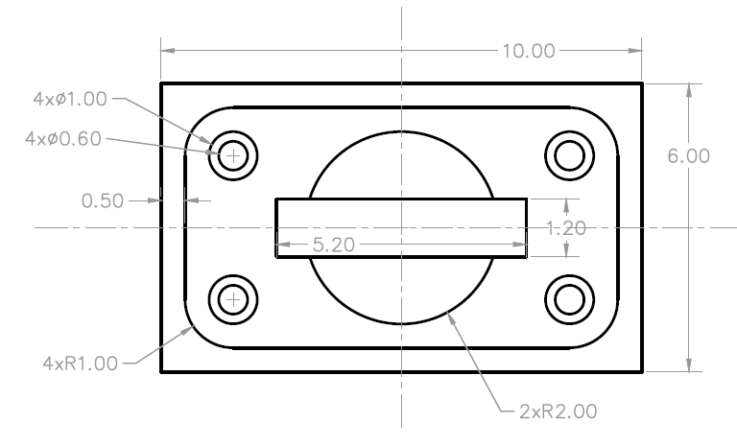
Lab 4 — the drawing you'll produce
You'll produce
The completed EX-3 drawing with mixed line/arc geometry drawn as clean, connected objects. (Commands: PLINE (Arc mode), ARC, ELLIPSE, SPLINE, XLINE, POINT/DIVIDE.)
Step-by-step
1. Open the EX-3 sheet (ex3-drawing-sheet.pdf) and plan the outline as one polyline
2. Draw the outline with PLINE, switching between Line and Arc segments as you go
PL → pick → A (arc) → L (line)
3. Place construction lines to project the centres of features between views
XL → H / V through centres
4. Add a three-point arc and a centre-start-end arc where the sheet shows open curves
A → 3 points · A → C
5. Draw the ellipse from its axis endpoints and a smooth spline through the fit points
EL → axis ends → half-width · SPL
6. Compare with ex3.dwg, purge the construction lines and save
ERASE xlines → SAVEAS ex3-mine.dwg
Check your work
The outline is a single polyline (one object when selected), arcs and the ellipse match the sheet dimensions, and no construction lines remain in the final drawing.
Note: This lab's data files and printable instructions are in labs/lab-04-polylines-arcs-ellipses-and-splines/.

Lab 5 — 2D Isometric Drawing
Objective: LO2 — produce 2D and 3D technical drawings using AutoCAD (A2, K2).
Goal: Use ISODRAFT to create a 2D isometric representation of the 3D object supplied in iso-object.dwg, switching isoplanes and drawing isocircles for the round features.
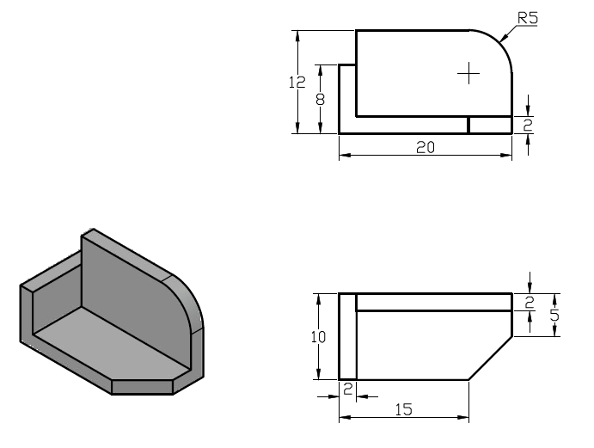
Lab 5 — the drawing you'll produce
You'll produce
A flat isometric drawing of the 3D object — edges on the three isoplanes plus isocircle holes. (Commands: ISODRAFT, isoplanes (F5), ELLIPSE Isocircle, polar tracking.)
Step-by-step
1. Open the object sheet iso-object-sheet.pdf and identify its three faces
2. Turn on isometric drafting from the status bar and set the Top isoplane
ISODRAFT → Isoplane Top (F5)
3. Draw the top face edges along the 30°/150° isometric axes with polar tracking
L with polar 30°/150°
4. Switch to the Right and Left isoplanes and complete the vertical faces
F5 → Right · F5 → Left
5. Add the round features as isocircles on the correct isoplane
EL → I (Isocircle) → centre → radius
6. Compare your isometric with the 3D model in iso-object.dwg and save
SAVEAS iso-mine.dwg
Check your work
Each face lies on the correct isoplane (edges at 30°/90°/150°), the isocircles read as ellipses aligned to their faces, and the drawing matches the supplied object's proportions.
Note: This lab's data files and printable instructions are in labs/lab-05-2d-isometric-drawing/.

Topic 03 — Modifying Objects (A3 · K3)
Move · Copy · Rotate · Offset · Mirror · Trim · Fillet · Arrays
Key concepts
- Relocate & duplicate — MOVE, COPY and ROTATE reposition objects from a base point to a second point or angle.
- Offset & mirror — OFFSET creates parallel copies at a set distance; MIRROR reflects half a symmetric design.
- Trim & extend — Quick and Standard modes cut objects back to, or extend them to meet, boundary edges.
- Fillet & chamfer — FILLET rounds a corner with a radius; CHAMFER bevels it with distances or an angle.
- Arrays — Rectangular, polar and path arrays distribute copies in rows/columns, around a centre, or along a curve.
- Stretch, scale & explode — STRETCH lengthens with a crossing window; SCALE resizes about a base point; EXPLODE breaks compounds.

Lab 6 — Move, Copy, Rotate and Offset
Objective: LO2/LO3 — modify 2D drawings efficiently to build up a design (A3, K3).
Goal: Build practice drawing EX-4 by drawing one feature and then positioning the rest with MOVE, COPY (multiple), ROTATE with reference angle and OFFSET for the parallel profiles.
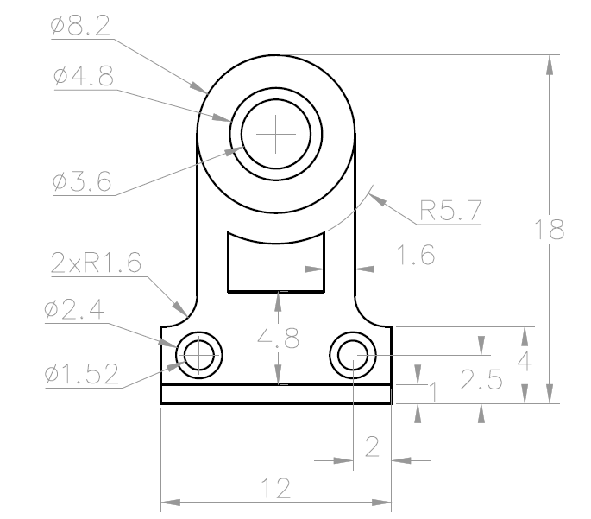
Lab 6 — the drawing you'll produce
You'll produce
The completed EX-4 drawing produced with modify commands rather than re-drawing each feature. (Commands: MOVE, COPY (Multiple/Array), ROTATE (Reference), OFFSET.)
Step-by-step
1. Open the EX-4 sheet (ex4-drawing-sheet.pdf) and spot the repeated features
2. Draw the base profile, then offset it to create the parallel inner/outer edges
O → distance → pick side
3. Draw one hole feature and copy it to every dimensioned centre
CO → base point → second points
4. Move a mis-placed feature precisely from its centre to the correct intersection
M → base → destination
5. Rotate the angled feature about its base point, using Reference to match the sheet angle
RO → base → R → ref angle → new angle
6. Check against ex4.dwg and save your version
SAVEAS ex4-mine.dwg
Check your work
Feature spacings measure correct with DIST, offsets are at the specified distances, and the rotated feature sits at exactly the sheet's angle.
Note: This lab's data files and printable instructions are in labs/lab-06-move-copy-rotate-and-offset/.

Lab 7 — Trim, Extend, Fillet and Chamfer
Objective: LO2/LO3 — clean up and finish drawing geometry (A3, K3).
Goal: Complete practice drawing EX-5 by trimming overlapping construction geometry, extending short edges to their boundaries, and finishing corners with fillets and chamfers.
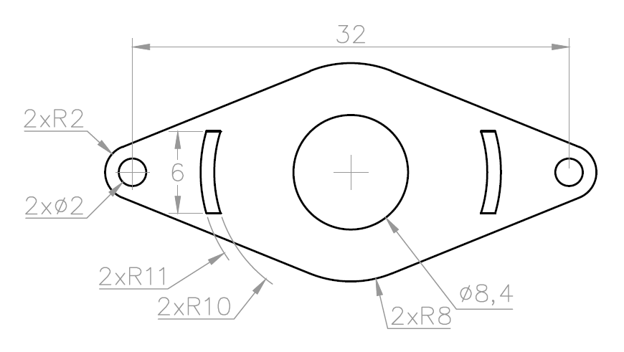
Lab 7 — the drawing you'll produce
You'll produce
A clean EX-5 profile with every corner finished exactly as dimensioned on the sheet. (Commands: TRIM (Quick/Standard), EXTEND, FILLET, CHAMFER, BREAK.)
Step-by-step
1. Open the EX-5 sheet (ex5-drawing-sheet.pdf) and rough out the profile with overlapping lines
2. Trim the overshoots in Quick mode — click or drag across the pieces to remove
TR → click segments
3. Use Standard mode where you need explicit cutting edges: select boundaries, then objects
TR → Enter (all edges) → pick
4. Extend the short edges to meet their boundary lines
EX → pick edges to extend
5. Fillet the rounded corners at the sheet radius, and chamfer the bevelled ones
F → R → 10 → pick 2 lines · CHA → D → 5,5
6. Compare with ex5.dwg and save
SAVEAS ex5-mine.dwg
Check your work
No overshooting or dangling segments remain (zoom around the whole profile), and every fillet radius / chamfer distance matches the drawing sheet.
Note: This lab's data files and printable instructions are in labs/lab-07-trim-extend-fillet-and-chamfer/.

Lab 8 — Mirror, Stretch, Scale and Arrays
Objective: LO2/LO3 — reproduce patterned and symmetric geometry (A3, K3).
Goal: Produce practice drawing EX-6 with mirror, stretch, scale and arrays, then inspect the supplied sawblade drawing to reverse-engineer a production polar-array pattern.
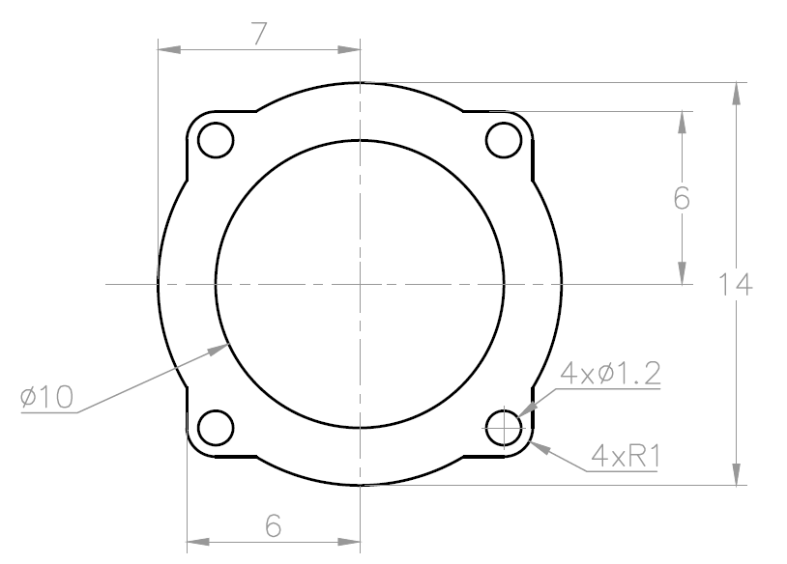
Lab 8 — the drawing you'll produce
You'll produce
The completed EX-6 drawing plus a verified sawblade polar array with the correct centre, item count, fill angle and associative state. (Commands: MIRROR, STRETCH (crossing window), SCALE (Reference), ARRAYRECT, ARRAYPOLAR.)
Step-by-step
1. Open the EX-6 sheet (ex6-drawing-sheet.pdf) and find its axis of symmetry
2. Draw one half of the outline, then mirror it across the centreline
MI → select → axis pt1 → pt2 → N
3. Array one hole into the rectangular pattern (rows, columns, spacing from the sheet)
AR → R → rows/cols/spacing
4. Distribute the bolt holes around the centre with an associative polar array
AR → PO → centre → items → 360 → Associative: Yes
5. Stretch the slot to its dimensioned length with a crossing window, scale a feature with Reference
S → crossing → base → distance · SC → R
6. Open sawblade.dwg, select its tooth array and record centre, item count, fill angle and associativity
OPEN sawblade.dwg → select array → PR
7. Verify against ex6.dwg and save
SAVEAS ex6-mine.dwg
Check your work
The two halves are symmetric, array counts and spacings match the sheet, the slot length is correct, and you can explain the four defining properties of the sawblade polar array.
Note: This lab's data files and printable instructions are in labs/lab-08-mirror-stretch-scale-and-arrays/.

Topic 04 — Organizing Objects (A4 · K4)
Object Properties · Layers · Blocks, Attributes & Reusable Content
Key concepts
- Object properties — Colour, linetype and lineweight — set ByLayer and inspected in the Properties palette (PR).
- Layers — The primary method of organising a drawing by function; control on/off, freeze/thaw, lock and plot.
- Grips — Multi-functional grips stretch, move, rotate, scale and copy objects without typing a command.
- Hide & isolate — Temporarily isolate the objects you are working on and hide the rest of the drawing.
- Blocks & attributes — Blocks are reusable symbols; attributes attach part numbers and data — the basis of part lists.
- External references — Xrefs attach another drawing (or PDF underlay) so teams share one live reference file.

Lab 9 — Object Properties and Layers
Objective: LO3/LO4 — organise a drawing with layers and properties (A4, K4).
Goal: Create a standards-based layer scheme in lab-table-lesson2.dwg, then audit the supplied office-plan-ground-floor.dwg to see how a larger architectural drawing separates systems.
You'll produce
A layered table drawing where every object is ByLayer, plus a five-layer audit of the office plan covering naming, colour, linetype, lineweight and plot state. (Commands: LAYER (LA), Properties palette (PR), Layer Walk, MATCHPROP, freeze/thaw, lock.)
Step-by-step
1. Open lab-table-lesson2.dwg and inspect current object properties
PR (Properties palette)
2. Create layers: A-OUTLINE, A-HIDDEN, A-CENTRE, A-DIMS, A-TEXT with colours and linetypes
LA → New Layer → colour/linetype
3. Load the HIDDEN and CENTER linetypes and set lineweights per layer
LA → Linetype → Load → HIDDEN, CENTER
4. Select objects by type and move them to their layers; copy formatting with MATCHPROP
select → Layer drop-down · MA
5. Practise layer states: turn off, freeze/thaw, lock and Layer Walk through the scheme
LAYWALK · LAYFRZ · LAYLCK
6. Set every object's colour, linetype and lineweight to ByLayer and save
SETBYLAYER → SAVEAS table-layers.dwg
7. Open office-plan-ground-floor.dwg and audit five functional layers against the same rules
OPEN office-plan-ground-floor.dwg → LA → record name/colour/linetype/lineweight/plot
Check your work
Turning each layer off hides exactly its objects, everything in table-layers.dwg reports ByLayer, and the office-plan audit identifies five layers with their intended functions.
Note: This lab's data files and printable instructions are in labs/lab-09-object-properties-and-layers/.

Lab 10 — Grips, Hide and Isolate
Objective: LO3/LO4 — edit and manage drawing objects directly (A4, K4).
Goal: Use multi-functional grips on EX-7, then practise isolate, hide, select-similar and end-isolate in the denser new-office-design.dwg without losing or deleting objects.
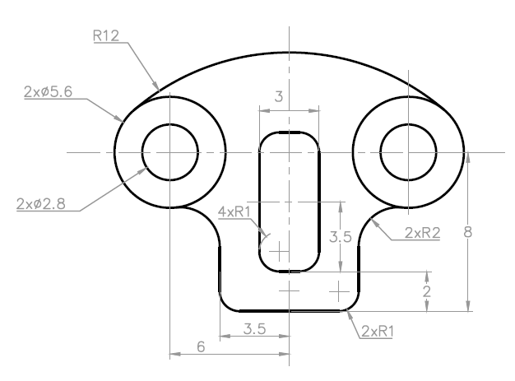
Lab 10 — the drawing you'll produce
You'll produce
An edited EX-7 layout plus a saved office-plan view in which the targeted object class was isolated, edited and fully restored. (Commands: Multi-functional grips, grip modes (Enter to cycle), Isolate/Hide Objects, Select Similar.)
Step-by-step
1. Open ex7.dwg, click an object and hover its grips to see the grip menu
2. Stretch an endpoint grip to lengthen an edge; use the midpoint grip to move the object
click grip → drag / type distance
3. Cycle grip modes with Enter: Stretch → Move → Rotate → Scale → Mirror
select grip → Enter to cycle
4. Copy a feature by grip-moving with the Copy option (or Ctrl held)
grip → Move → C (Copy)
5. Open new-office-design.dwg, select one furniture object and use Select Similar
OPEN new-office-design.dwg → select → right-click → Select Similar
6. Isolate the selection, make one grip edit, hide a second class, then restore everything
ISOLATEOBJECTS · HIDEOBJECTS · UNISOLATEOBJECTS
Check your work
You can stretch, move, rotate and copy with grips alone; after UNISOLATEOBJECTS, the office drawing's object count and layer visibility match the starting state except for your saved edit.
Note: This lab's data files and printable instructions are in labs/lab-10-grips-hide-and-isolate/.

Lab 11 — Blocks, Attributes and Part Lists
Objective: LO3 — create part lists using AutoCAD (A4, K4).
Goal: Inspect a reusable block library and a drawing containing dynamic blocks, then define a part-tag block with attributes and prepare its data for the part list.
You'll produce
A BALLOON block with PART_NO / DESC / QTY attributes, plus evidence that one library block and one dynamic-block state can be inserted and edited correctly. (Commands: BLOCK, WBLOCK, DesignCenter, ATTDEF, INSERT, ATTEDIT, dynamic-block grips, DATAEXTRACTION.)
Step-by-step
1. Open architecture-library.dwg in DesignCenter and insert one reusable symbol into a new drawing
ADCENTER → Folders → architecture-library.dwg → Blocks → Insert
2. Open new-office-dynamic-blocks.dwg and change one dynamic block's grip or visibility state
OPEN new-office-dynamic-blocks.dwg → select dynamic block → grip / Properties
3. Open title-block.dwg and draw the balloon symbol (circle + leader stub)
C → radius 5
4. Define attributes PART_NO, DESC and QTY with prompts and default values
ATTDEF → tag/prompt/default
5. Create the block BALLOON from the circle plus its attribute definitions
B → name BALLOON → select objects
6. Insert the balloon against each component and fill in the attribute values
I → BALLOON → answer prompts
7. Edit one balloon attribute, then preview the data extraction used by the Lab 14 part list
ATTEDIT / EATTEDIT → DATAEXTRACTION
Check your work
The library block inserts at the correct scale, the dynamic state changes without exploding, and Data Extraction lists one row per BALLOON with the values you entered.
Note: This lab's data files and printable instructions are in labs/lab-11-blocks-attributes-and-part-lists/.

Lab 12 — External References and PDF Import
Objective: LO4 — assemble drawings from shared reference content (A4, K4).
Goal: Repair and verify the relative Landscaping_REV1 Xref in the supplied office-layout host, then attach a title block and a PDF underlay and import vector geometry.
You'll produce
A host drawing whose landscaping Xref resolves from the lab folder, with an additional live title-block Xref and an imported PDF geometry sample. (Commands: XREF/ATTACH, External References palette, PDFATTACH, PDFIMPORT.)
Step-by-step
1. Keep new-office-layout-with-xref.dwg and Landscaping_REV1.dwg together, then open the host
OPEN new-office-layout-with-xref.dwg
2. Open External References and confirm Landscaping_REV1 is Found using a relative path
XR → Landscaping_REV1 → Saved Path: .\Landscaping_REV1.dwg
3. If unresolved, select a new path in the current lab folder, reload, and retain a relative path
XR → Change Path → Select New Path → Reload
4. Attach title-block.dwg as an additional Xref at 0,0, scale 1
XATTACH → title-block.dwg
5. Attach the supplied drawing-sheet PDF as an underlay and snap to its geometry
PDFATTACH → ex1-drawing-sheet.pdf
6. Import the PDF's vector geometry into the drawing and inspect the created objects
PDFIMPORT → select underlay area
Check your work
Both Xrefs show Loaded, Landscaping_REV1 uses a relative path and survives reopening the folder elsewhere, while PDFIMPORT produces editable AutoCAD objects from the underlay.
Note: This lab's data files and printable instructions are in labs/lab-12-external-references-and-pdf-import/.

Topic 05 — Design Documentation (A5 · K5)
Text · Dimensions · Tables & Part Lists · Layouts, Viewports & Plotting
Key concepts
- Text & text styles — Single-line and multiline text; a text style controls font, height and justification centrally.
- Dimensions — Linear, aligned, angular, radial, diameter, ordinate and arc-length dimensions annotate real sizes.
- Dimension styles — A named collection of settings — arrowheads, text placement, tolerances — applied consistently.
- Multileaders & clouds — Multileaders point notes at features; revision clouds flag changed areas for checking.
- Tables & part lists — TABLE creates row/column data such as bills of materials extracted from block attributes.
- Layouts & plotting — Scaled viewports on a titled layout sheet, printed with PLOT or published to PDF/DWF.

Lab 13 — Text and Text Styles
Objective: LO4 — create AutoCAD design documentation (A5, K5).
Goal: Annotate the layered table drawing with single-line and multiline text, create and apply text styles for titles and notes, and fill in the title-block fields.
You'll produce
An annotated drawing with consistent TITLE and NOTES text styles and a completed title block. (Commands: TEXT, MTEXT, STYLE, annotative text, SPELL.)
Step-by-step
1. Open your table drawing and create text styles TITLE (Arial, 5mm) and NOTES (Arial, 2.5mm)
ST → New → font/height
2. Add the drawing title with single-line text on the A-TEXT layer
DT → start point → height → rotation
3. Add a general-notes paragraph with multiline text in a bounding box
T (MTEXT) → pick corners
4. Set the NOTES style current and re-style existing text via the Properties palette
PR → Style → NOTES
5. Fill in the title-block fields: title, drawn-by, date, scale, sheet number
double-click text → edit
6. Spell-check the drawing and save
SPELL → SAVE
Check your work
All annotation uses your named styles (none on Standard), the title block is complete, and changing the NOTES style font updates every note at once.
Note: This lab's data files and printable instructions are in labs/lab-13-text-and-text-styles/.

Lab 14 — Dimensions, Multileaders and Part-List Tables
Objective: LO3/LO4 — dimension drawings and produce part lists (A5, K5).
Goal: Fully dimension practice drawing EX-8 with a metric dimension style — linear, aligned, radial, diameter, angular, continue and baseline — add multileader callouts, and create the part-list table from the Lab 11 balloon attributes.
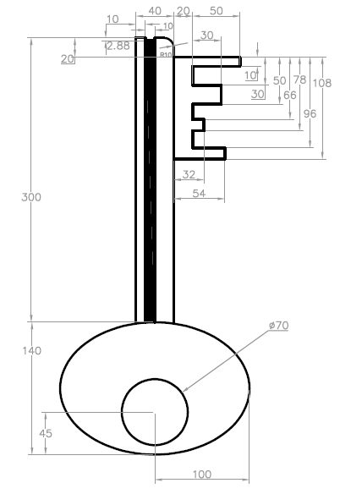
Lab 14 — the drawing you'll produce
You'll produce
A fully dimensioned EX-8 sheet with leader notes and a parts table (part no · description · qty). (Commands: DIMSTYLE, DIM, DLI/DAL/DRA/DDI/DAN, DCO/DBA, MLEADER, TABLE, DATAEXTRACTION.)
Step-by-step
1. Open ex8.dwg and create dimension style MECH-25 (ISO, 2.5mm text, closed-filled arrows)
D (DIMSTYLE) → New → fit/text
2. Place linear and aligned dimensions on the main edges
DLI · DAL
3. Dimension the circles and arcs with diameter, radius and angular dimensions
DDI · DRA · DAN
4. Chain related dimensions with Continue, and datum-reference them with Baseline
DCO · DBA
5. Add multileader callouts for the hole notes and edge finishes
MLD → arrow point → landing → note
6. Insert a table for the part list and populate it from the Lab 11 attribute extraction
TB (TABLE) · DATAEXTRACTION
7. Add a revision cloud around one detail to flag it for checking, then save
REVCLOUD → drag around detail
Check your work
Every dimension on the EX-8 sheet is reproduced with the MECH-25 style (no overridden text), leaders land neatly, and the table rows match the balloons one-for-one.
Note: This lab's data files and printable instructions are in labs/lab-14-dimensions-multileaders-and-part-list-tables/.

Lab 15 — Hatching and Detail Finishing
Objective: LO5 — produce design specification using AutoCAD (A5, K5).
Goal: Apply section hatching with controlled boundaries and islands, then compare two supplied landscaping revisions and mark the changed area with a revision cloud and note.
You'll produce
A correctly hatched section view plus a documented landscaping revision showing the changed geometry, revision cloud and concise change note. (Commands: HATCH, gradient fills, boundary/island detection, HATCHEDIT, DWG Compare, REVCLOUD, MLEADER.)
Step-by-step
1. Open a drawing with closed profiles (reuse ex3-mine.dwg) and identify the cut areas
2. Hatch the main section area with ANSI31 at a scale that reads clearly
H → Pattern ANSI31 → pick point
3. Set different angles for adjacent parts so the section reads unambiguously
H → Angle 90 → pick point
4. Control islands: hatch around text and holes using island detection
H → Settings → Island detection
5. Apply a two-colour gradient fill to the elevation face for presentation
GRADIENT → colours → pick area
6. Edit an existing hatch's pattern and scale, then save
HATCHEDIT → new scale
7. Compare landscaping-rev1.dwg with landscaping-rev2.dwg and isolate the changed geometry
COMPARE → landscaping-rev2.dwg
8. Cloud the change and add a concise multileader note before saving the review copy
REVCLOUD → MLEADER → SAVEAS landscaping-review.dwg
Check your work
Hatches do not bleed, adjacent parts use distinct angles, islands remain clear, and the landscaping review identifies every revision with one cloud and one readable note.
Note: This lab's data files and printable instructions are in labs/lab-15-hatching-and-detail-finishing/.

Lab 16 — Layouts, Viewports and Plotting
Objective: LO5 — produce drawings for submission to standards (A5, K5).
Goal: Audit the supplied new-office-layout.dwg, then compose an A3 layout with a title block, locked scaled viewports and a standards-compliant PDF plot.
You'll produce
A print-ready A3 office layout with two locked viewports, completed title information, verified lineweights and a plotted PDF. (Commands: LAYOUT, PAGESETUP, MVIEW, viewport scale/lock, PLOT, DWG to PDF.pc3.)
Step-by-step
1. Open new-office-layout.dwg, inspect its model/layout tabs and save a working copy
OPEN new-office-layout.dwg → SAVEAS office-layout-mine.dwg
2. Rename the working layout A3-SHEET and set DWG To PDF.pc3, ISO A3 landscape, 1:1
PAGESETUP → Modify
3. Insert the title block on the layout at 0,0 in paper space
I → title-block
4. Create a main viewport and set its scale to 1:20 exactly, then lock it
MV → drag → select → scale 1:20 → lock
5. Add a second, smaller viewport for a detail at a larger scale
MV → drag → scale 1:5
6. Plot the layout to PDF and check line weights in the output
PLOT → DWG To PDF.pc3 → OK
Check your work
Both viewports report their exact scales in the status bar and cannot be zoomed when locked, and the plotted PDF shows the complete titled sheet at A3.
Note: This lab's data files and printable instructions are in labs/lab-16-layouts-viewports-and-plotting/.

Reading Technical Drawings — Quick Reference
These conventions (K1/K3) apply across every lab and are assessed in the written assessment.
- Line conventions: continuous thick = visible outline; dashed = hidden detail; chain thin = centreline; continuous thin = dimensions, hatching and projections.
- Orthographic projection presents related 2D views (front, top, side) aligned by projection; third-angle and first-angle layouts differ by where the top/side views sit.
- Isometric drawings show three faces at once with receding axes at 30° — a pictorial view, not a true 3D model.
- Section views cut through the object; the cut material is hatched (e.g. ANSI31) with adjacent parts hatched at different angles.
- Dimensions state real object size regardless of plotted scale; never measure a printed sheet with a ruler.
- The title block records the drawing title, number, scale, units, author, date, revision and sheet size.

Preparing for the Assessment
- First pass: complete every lab following this guide, checking each 'Check your work' test.
- Second pass: redo Labs 2–8 from just the drawing-sheet PDFs, without the step-by-step instructions.
- Review the Key Concepts bullets of each topic — the written assessment (SAQ) draws on them.
- The practical performance asks you to produce a dimensioned technical drawing end-to-end: set up, draw, modify, organise with layers, dimension, and plot — Labs 2, 7, 9, 14 and 16 cover that chain.
- Course materials, assessment submission and your certificate are on the LMS: https://lms-tms.tertiaryinfotech.com

Glossary
- Model space — The unlimited drawing environment where designs are drawn at full (1:1) size.
- Paper space / Layout — The sheet-composition environment where scaled viewports, title blocks and notes are arranged for printing.
- Viewport — A window on a layout that displays a view of model space at a set scale.
- Workspace — A task-oriented arrangement of ribbons, menus and palettes (e.g. Drafting & Annotation).
- Object snap (Osnap) — Precision aid that picks exact geometric points — endpoints, midpoints, centres, intersections.
- Polar tracking — Guides the cursor along preset angle increments while drawing.
- Polyline — A single object made of connected line and arc segments.
- Isometric drawing — A flat 2D drawing that represents a 3D object using axes at 30°/90°/150° (ISODRAFT).
- Layer — A named organising level that controls the colour, linetype, lineweight, visibility and plottability of the objects on it.
- Block — A named, reusable group of objects inserted as one unit; dynamic blocks add adjustable parameters.
- Attribute — A text data tag attached to a block — part number, description, quantity — extractable into tables.
- External reference (Xref) — Another drawing attached live into the current drawing rather than copied in.
- Dimension style — A named collection of dimension settings (arrows, text, units) applied consistently across a drawing.
- Multileader — An annotation object combining an arrowhead, leader line, landing and note text.
- Hatch — A pattern, solid or gradient fill applied to an enclosed area, e.g. to show cut material in sections.
- Plot — Output a drawing to a printer/plotter or to a file such as PDF; plotting is configured per layout.

